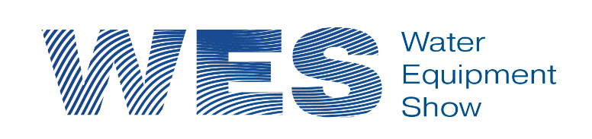
13th May 2027, International Centre, Telford
(WES Conference Dinner – Evening 12th May 2027)

The Water Equipment Show - one of the most comprehensive events in the Water Industry calendar

GOLD EXHIBITION SPONSORSHIP
The Water Equipment Show (WES) has up to 20 Gold sponsorships available who will each have:
- Choice of exhibition stand location with up to 48m² (8m x 6m) carpeted exhibition space with £600 discount for services provided by Stagecraft UK (our selected event team)
- Their lunch delivered direct to their stand on the day of the show
- The option to provide a branded slide for the scrolling presentation which will be displayed during the WES Conference Dinner
- Their logo visible at the WES Conference Dinner and in the WES Conference & Exhibition areas
- The opportunity to work with the Pump Centre’s social media team to promote their presence at the event
- A presence on the WES website
- A vote of thanks at the beginning of the event
- Advert in the WES event guide
- Regular posts on social media channels
- A presence in the event “Show Guide”
Cost of Gold Sponsorship: £9,750.00 (Ex VAT)

Cost of Gold Sponsorship including a table for up to 10* persons at the Conference Dinner: £10,450.00 (Ex VAT)
*Includes 3 free dinner places

SILVER EXHIBITION SPONSORSHIP
The Water Equipment Show (WES) has up to 32 Silver sponsorships available who will each have:
- Choice of exhibition stand location with up to 24m² (6m x 4m) carpeted exhibition space with £300 discount for services provided by Stagecraft UK (our selected event team)
- The option to provide one branded slide for the scrolling presentation that will be display during the WES Conference Dinner
- Their logo visible at the WES Conference Dinner and in the WES Conference & Exhibition areas
- A presence on the WES website
- A vote of thanks at the beginning of the event
- Regular posts on social media channels
- A presence in the event “Show Guide”
Cost of Silver Sponsorship - £6,750.00 (Ex VAT)

Cost of Silver Sponsorship including a table for up to 10* persons at the Conference Dinner £7,550.00 (Ex VAT)
*Includes 2 free dinner places
Early booking discount of £150.00 will be applied to the above prices for those who book and pay by 26th June 2026

To discuss further and reserve your sponsorship package please contact one of the Pump Centre team as follows:
Telephone: 01925 964030 / Email: ………………….. / Website: https://www.pumpcentre.com/contact

